AMEC M3 Measurement Maturity Mapper: Online Application Briefing Guide

# Overview

The Measurement Maturity Mapper or M3 is an initiative from the International Association for the Measurement and Evaluation of Communications (AMEC) that was launched at the Global Summit on Measurement in Barcelona in June 2018. M3 enables communications professionals to understand how sophisticated their communications measurement programmes are compared to peers in the industry and provides guidance on how to improve this practice in order to provide greater value.

Background materials from the Barcelona Summit are available here:

**M3 Workshop Slide Deck:**

<https://2018.amecglobalsummit.org/wp-content/uploads/2018/06/1130-Workshop-F-AMEC-M3-Measurement-Maturity-Mapper.pdf>

**M3 Workshop Video:**

*TBC*

The next stage of the M3 initiative is to develop an online application, available from the AMEC website ([www.amecorg.com](http://www.amecorg.com)) that will allow users to log in and answer a questionnaire that will give them a set of scores to show their current level of sophistication and how this compares against a data set of other users who have also filled in the questionnaire. The application would then highlight what the user does well and suggest areas that they can improve based on their specific answers.

The current timeline for the launch of the online application is for AMEC’s [Measurement Month](https://amecorg.com/measurement-month-2018/) in November 2018.

**Contacts:**

Paul Hender: e-mail: [paulhender1973@gmail.com](mailto:paulhender1973@gmail.com), phone: 07535 965 014

Colin Wheeler: email: [colin.wheeler@understandingexpertise.com](mailto:colin.wheeler@understandingexpertise.com), phone: 07958 322092

Ben Levine: [ben.levine@trueglobalintelligence.com](mailto:ben.levine@trueglobalintelligence.com), phone: 0790 481 2078

# Use Cases

Use Cases are split into two phases – Phase 1, covers priority use cases to get a working application in place in a shorter time frame. Phase 2, covers additional use cases that can follow on at a later stage once phase 1 has been implemented. Phase 2 requirements should be considered when building Phase 1 to prevent the need for a significant redesign of the initial build to facilitate Phase 2.

# Priority Use Cases (Phase 1)

* 1. The user needs to set up a user name (e-mail address) and password to access the online application. The user should be able to log back in in the future and to be able to see data that they have entered and used historically
  2. Once logged in the user should be guided through a diagnostic questionnaire hosted on the application site. An existing online version of the questionnaire is available here for reference:

<https://understandingexpertise.uk/index.php/144319?lang=en>

The questionnaire should be divided into separate pages for each section so that it is easier for the user to fill out. The questionnaire should store the data as the user progresses, so that it will be remembered if the user needs to leave the application and come back at a later stage

At the end of the questionnaire, the user should be asked for permission for their data to be used anonymously as part of the overall data set

* 1. Each possible response to each question would have a score associated with it. Each question would also be attributed to one of three dimensions: **Reporting**, **Planning** and **Impact.** Based on the response that the user chooses for each question the user would then get a score for each question. See the associated spreadsheet **AMEC M3 Measurement Maturity Mapper Question Scoring** for specific detail.

The application should be configured so that the scores can be adjusted if necessary. It is envisaged that this will be done by storing the scores in a database which could be edited by a database administrator – there should not be a need for a UI for adjusting the scores.

Once the questionnaire is completed and submitted, the application would be able to total the scores for each question and provide a score for each of the three dimensions based on the following calculation (example shown for the ‘Reporting’ dimension):

**‘Reporting’ Score = 100 x (Total score for ‘Reporting’ associated questions)/(Maximum possible score for ‘Reporting’ associated questions).**

As well as a score for each dimension, the application would also be able to provide a total overall score based on a weighted average of the scores of the three dimensions. The application should be configured so that these weightings could be adjusted if necessary (if they are stored in a database then by a database administrator). The current weightings are:

**Total score = (Reporting Score x 30%) + (Planning Score x 30%) + (Impact Score x 40%)**

The three dimension scores plus the total score should be saved to a database – so that the user can access the scores in the future and, if permitted, that the scores would contribute to an overall data set.

* 1. 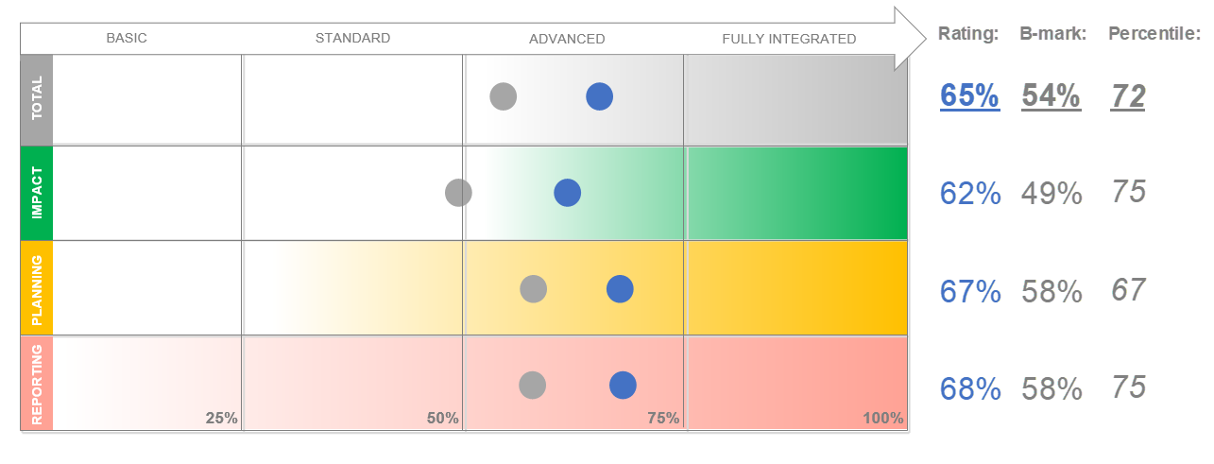The scores would be presented back to the user in an intuitive and engaging graphical way. For the AMEC Summit Workshop, the scores were presented like this (see M3 Workshop Slide Deck link at the beginning of this document)

The four scores from the user are shown against a benchmark of the average scores of the overall data set together with what percentile the user score is. In the above example the total score is 65% against a benchmark of 54% and is in the 72nd percentile (demonstrating that the score is better than 72% of the overall dataset).

* 1. The application would then offer the user a series of recommendations based on their specific answers to the questionnaire. The recommendations would be split into ‘strengths’ and ‘opportunities’ for each dimension. ‘Strengths’ are based on individual question scores that are higher than or equal to a ‘strength threshold’ for that question. Conversely ‘opportunities’ are based on individual question scores that are lower than or equal to an ‘opportunity threshold’ for that question. A maximum of five ‘strength’ and five ‘opportunity’ recommendations would be presented for each dimension. These would be based on a priority order for the strengths and weaknesses respectively. See the associated spreadsheet **AMEC M3 Measurement Maturity Mapper Question Scoring** for specific detail. For the AMEC Summit Workshop, the recommendations were presented like this (see M3 Workshop Slide Deck link at the beginning of this document)

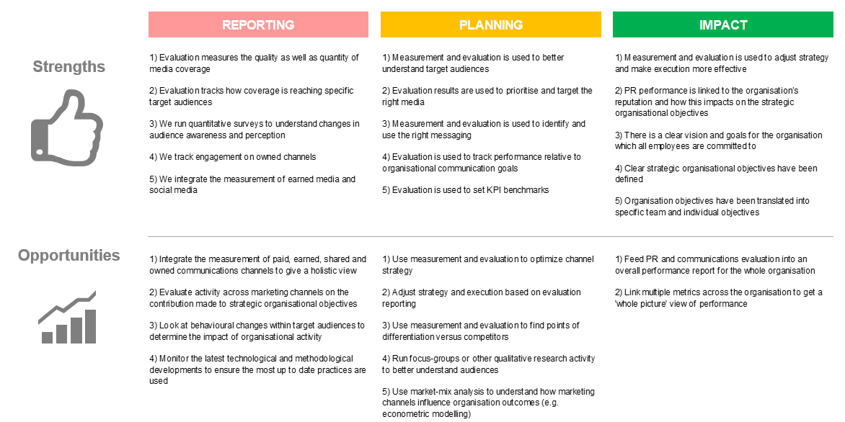

* 1. The user should be able to add multiple versions of the questionnaire – either so that they can track improvement over time or for if they work in an agency, so they can fill in a questionnaire for different clients. Questionnaires should be recorded with a manually inputted title as well as a timestamp to facilitate both scenarios.
  2. The user should have a simple ‘file’ style management system to be able to create, edit and delete questionnaires. The user should also be able to take an existing questionnaire and be able to ‘save as’ a new questionnaire so that, for example, they can have different versions representing different points in time. (eg this year compared to last year).
  3. The user should be able to print out their scores and recommendations into a well-presented pdf format (one or two pages)
  4. A database administrator should be able to access and edit the data set including all responses to the questionnaire, scores for individual questions (1.3) and the weighted averages for the total score (1.3). It is envisaged that the data for the application will be stored in a SQL-based relational database management system such MS SQL Server or MySQL.

The database administrator would need to be able to import an existing initial data set of responses, currently in an excel spreadsheet, mapped to the new data structure of the database.

* 1. The whole application and database should be hosted in an environment that can be accessed by a future development team and database administrator (the latter for database access).

# Additional Use Cases (Phase 2)

* 1. The user should be able to choose the data set that they want to compare their scores to. They would do this by creating a sub-dataset based on a series of filters including sector, region, size of organisation and type of organisation.

When the user uses these filters, the application will show who many responses are in the sub-dataset and will not be able to precede if this number falls below a certain threshold. A database administrator should be able to edit this number - it is suggested that this threshold is 10 initially.

Additional Useful Information

The Measurement Maturity Mapper is a tool designed to support two other key AMEC initiatives – the **Barcelona Principles 2.0** and the **Integrated Evaluation Framework**. More information about these two initiatives is available on the AMEC website:

**Barcelona Principles 2.0:** <https://amecorg.com/barcelona-principles-2-0/>

**Integrated Evaluation Framework:** <https://amecorg.com/amecframework/>

The Barcelona Principles 2.0 are a set of seven statements guiding best practice in communications measurement while The Integrated Evaluation Framework is an interactive online application that takes users on a set of logical steps to build their own communications measurement framework aligned around organisational strategic objectives.

# About AMEC

AMEC is the International Association for Measurement and Evaluation of Communication.

It is the world’s largest media intelligence and insights professional organisation, representing organisations and practitioners who provide media evaluation and communication research. AMEC currently has more than 160 members in 86 countries worldwide.

AMEC thinks and operates internationally, forming working groups from different countries to work together on new initiatives, all reinforced by its International Chapters in Asia Pacific, North America and Europe.

The AMEC logo is regarded as an international mark of excellence in the provision of media evaluation and communication research services to clients.

AMEC’s pioneering work in the field has included the development of the Barcelona Principles; Barcelona Principles 2.0 and most recently the launch of the AMEC Integrated Evaluation Framework.